" Of the fall 2013 first-time cohort of 2,795 students, 875 (31%) enrolled in Math 112, and 677 (24%) enrolled in Math 114 within their first academic year. …
Data shows that about one-fourth of the students in these courses do not complete it successfully, and many more earn grades that are below the threshold for entrance into subsequent science and math courses.

Grades in Entry-Level Math Classes
Year | Math 112 |  |  | Math 114
 | Total Enrolled | Percent  W or F | Percent  W, F or D | Total Enrolled | Percent  W or F | Percent  W, F or D
2011-12 | 1,356 | 20% | 36% | 1,268 | 28% | 40%
2012-13 | 1,309 | 25% | 41% | 1,236 | 29% | 39%
2013-14 | 1,422 | 27% | 45% | 1,167 | 23% | 35%

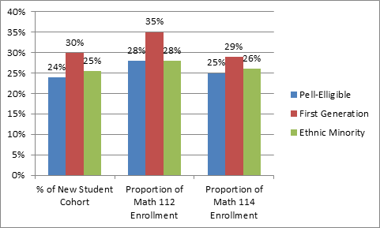
The proportion of students in these courses who belong to traditionally underserved or at-risk populations is higher in these courses than in the general population. Particularly for Math 112, the students enrolling in 2013-14 are more often PELL-eligible, first-generation and ethnic minority than the cohort of fall 2013 entering first-time students.

Proportion of Underserved or At-Risk Students
Fall 2013 First-Time Students | Number of Students | Proportion of New Student Cohort | Proportion of Math 112 Enrollment | Proportion of Math 114 Enrollment
All | 2,795
Pell-Eligible | 667 | 24% | 28% | 25%
First Generation | 835 | 30% | 35% | 29%
Ethnic Minority | 711 | 25% | 28% | 26%

The course outcomes for these subset populations tends to be even lower than the group of all students enrolled in these courses. We see that for students who took Math 112 in the 2013-14 year, 45% received a grade of withdrawal, failure or D. Fifty percent of the group of PELL-eligible students received this poor outcome, as well as 53% of first-generation and 48% of the ethnic minority students.

Grades for Underserved or At-Risk Students
2013-14 | Math 112 |  |  | Math 114
 | Total Enrolled | Percent  W or F | Percent  W, F or D | Total Enrolled | Percent  W or F | Percent  W, F or D
All Students | 1,422 | 27% | 45% | 1,167 | 23% | 35%
Pell-Eligible | 402 | 30% | 50% | 296 | 24% | 38%
First Generation | 500 | 32% | 53% | 343 | 25% | 39%
Ethnic Minority | 401 | 30% | 48% | 300 | 27% | 41%



