To whom it may concern,

I am writing to advocate for the use of Open Educational Resources (OER) at Western Washington University. I work for the Center of Instructional Innovation and Assessment as the OER Research Assistant at Western. In this position, I help Western faculty to find and develop their own OER for instruction use in Western classes.

Open educational resources are most commonly thought of as free or alternative textbooks but are much more than that! OER include every type of educational media such as: journal articles, images, podcasts, ebooks, teaching materials, data and more. Open educational resources are defined by the open licenses that are attached to them. OER are typically media that exist in the public domain (really old media that has no or expired copyright) or media with Creative Commons licenses. These licenses give the user the ability to use and distribute the material for free without breaking copyright laws. Many licenses also allow for the modification of materials to suit the needs of the user.
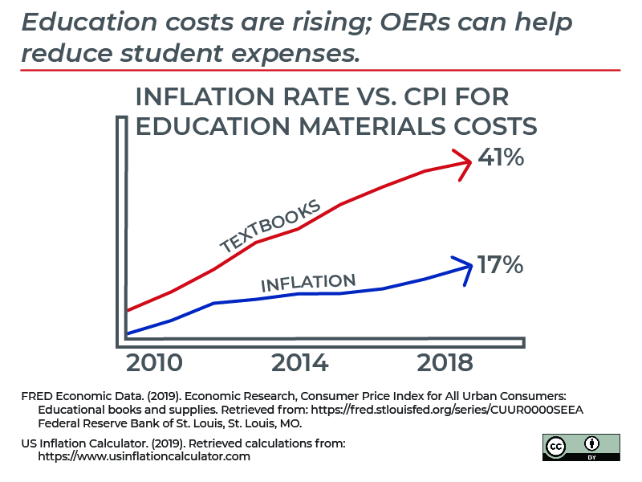
The most well known benefit of using OER course materials savings for students. In the US, during the 2017-2018 academic year, students spent an average of $484 on textbooks. While used textbooks and rental textbooks help lower the cost of course materials, a study in 2013 by the Student PIRG found that 65% of students have chosen not to buy a textbook because of costs. Some students choose their courses based on the cost of the course materials rather than what they would like or need to take. Additionally, while it is cheaper for some students to buy used or rental texts, this doesn’t take into account the increasingly common paywalls for course materials that require individual “web codes” that unlock access to online, quizzes, tests, and other study materials. OER provides a way to exponentially lower course material costs for students, creating more equitable access to information. Other benefits of OER for professors and students include: greater control over the course material, using up-to-date research, and providing access to research post-graduation. Many professors don’t use the entire textbook or supplement textbooks because they feel the information that they contain is incomplete. Giving professors the power to produce or curate their own text gives professors control to teach what they feel is most valuable in a 10 or 11 week quarter. Offering professors an easy way to alter course materials means that professors can include texts that represent non-dominant viewpoints who may not be represented in canon texts. Finally, using OER allows professors to use research that is very current. This is especially important in fields that change rapidly (such as technology and the sciences) where published textbooks become almost immediately dated as soon as they are published. Using OER texts also gives students access to the text from the course after they graduate when they lose access to many other library and journal texts.

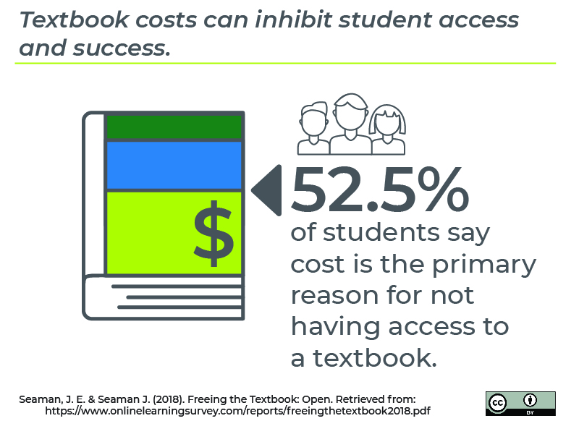
Washington State is one of the leading states implementing OER in college courses, developing policy around the use of OER in higher education, in the United States. Specifically, Washington community colleges have been instrumental in leading the implementation and use of OER in college courses. Different community colleges in California and Arizona are implementing “Z-Degrees” which are specific programs where students can earn an AA and graduate spending no money on textbooks because all courses were designed with OER texts. Community Colleges that are using OER in their courses are starting to find higher course completion rates, faster degree completion, and high grades for students. The Washington State legislature is currently in the process of requiring community colleges to mark courses as OER or low-cost in course catalogs. The State Board of Community and Technical Colleges is in the process of releasing a labeling tool that allows community colleges to label their courses as either OER or low-cost. At Western, we would love an effort to see something similar.

Efforts to support Open Educational Resources (OER) efforts at Western Washington University started in 2016, with a few faculty receiving grants each year to focus on transforming course materials for large GUR courses to using open or alternative textbooks. Over the past few years, 16 high impact Western courses have been transformed saving students an approximated $1.4 million from 2016-2019. The Center for Instructional Innovation at WWU estimated that in just the 2019-20 school year alone, over 5,000 Western students will take a course that is free or low-cost, saving students over $700,000 in textbooks costs (CIIA, 2019). This number is predicted to have a cumulative impact as more courses transition to using open educational resources and as additional courses transition to using open educational resources.

For more information about OER at Western contact:
- Ali Holmes, holmesa6@wwu.edu
- Justina Brown, jbrown@wwu.edu
- Jenny Oleen, oleenj@wwu.edu

Potential list of people to send to:
- David Patrick, Dean of Research and the Graduate School
- Scott Young, Dean of College of Business and Economics
- Jack Herring, Dean of Fairhaven College of Interdisciplinary Studies
- Kit Spicer, Dean of Fine and Performing Arts
- Steve Hollenhorst, Dean of Huxley College of the Environment
- Paqui Paredes Méndez, Dean of College of Humanities and Social Sciences
- Brad Johnson, Dean of College of Science and Engineering
- Horacio Walker, Dean of Woodring College of Education
- Mark Greenberg, Dean of Western Libraries

- Audrey Taylor, Department Chair of Accounting
- Craig Tyran, Department Chair of Decision Sciences
- Matthew Roelofs, Department Chair of Economics
- Ed Love, Department Chair of Finance and Marketing
- Jongwook Kim, Department Chair of Management
- Julia Sapin, Department Chair of Art History and Art
- Patrick Roulet, Department Chair of Music
- Beth Leonard, Department Chair of Theatre
- David Wallin, Department Chair of Environmental Science
- Gracy Wang, Department Chair of Environmental Studies
- Steve Woods, Department Chair of Communications

Kathryn Vulić, Department Chair of English
- Kimberly Lynn, Department Chair of Global Humanities and Religions
- Johann Neem, Department Chair of History
- Jennifer Keller, Department Chair of Journalism
- Shannon Dubenion-Smith, Department Chair of Modern and Classical Languages
- Ryan Wasserman, Department Chair of Philosophy
- Todd Koetje, Department Chair of Anthropology
- Kimberly Peres, Department Chair of CSD
- Keith Russell, Department Chair of Health and Human Development
- Kristin Denham, Department Chair of Linguistics
- Amir Abedi, Department Chair of Political Science
- James Graham, Department Chair of Psychology
- Mick Cunningham, Department Chair of Sociology
- Merrill Peterson, Department Chair of Biology
- Spencer Anthony-Cahill, Department Chair of Chemistry
- Phil Nelson, Department Chair of Computer Science
- Jeff Newcomer, Department Chair of Engineering and Design
- Bernie Housen, Department Chair of Geology
- Janelle Leger, Department Chair of Physics
- Tjalling Ypma, Department Chair of Mathematics
- Tracy Coskie, Department Chair of ELED
- John Korsmo, Department Chair of Health and Community Studies
- Charles Lambert, Department Chair of Special Education and Education Leadership
- Kevin Roxas, Department Chair of Secondary Education

