SEJF 2019-2020 Internal Feedback and Key Points

Training
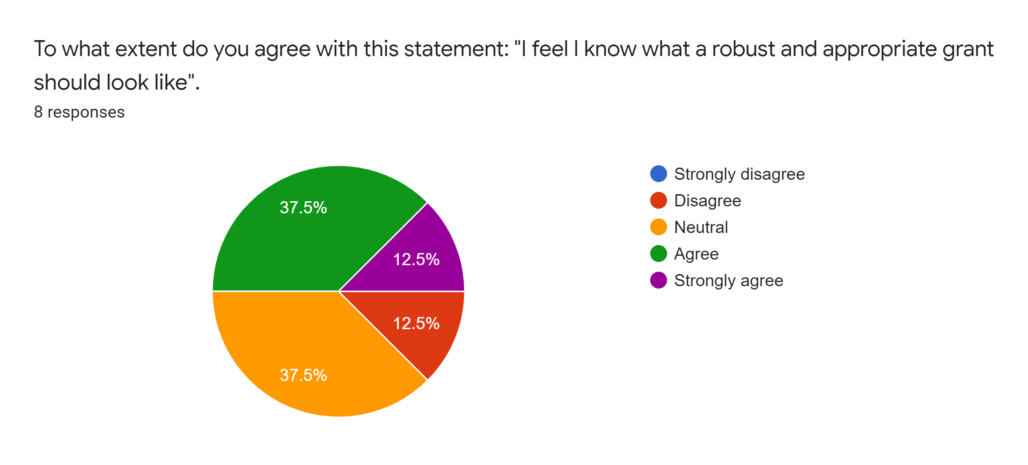
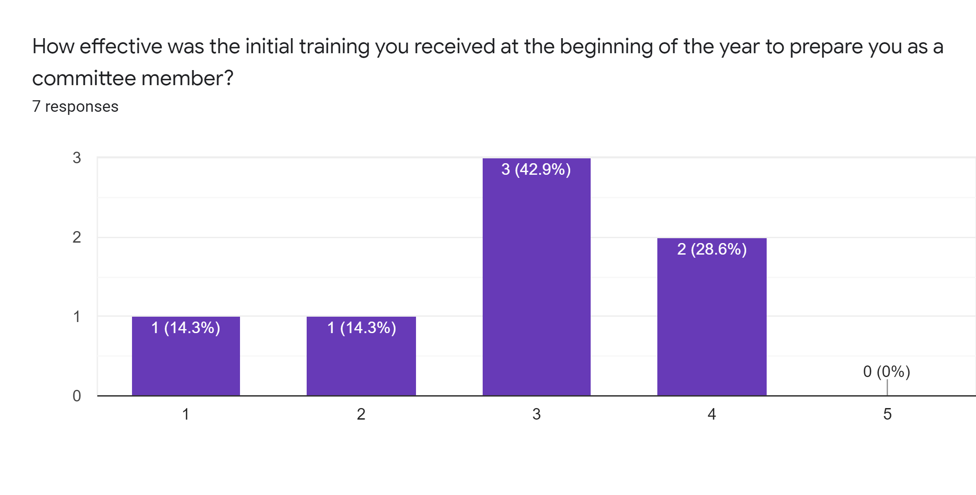
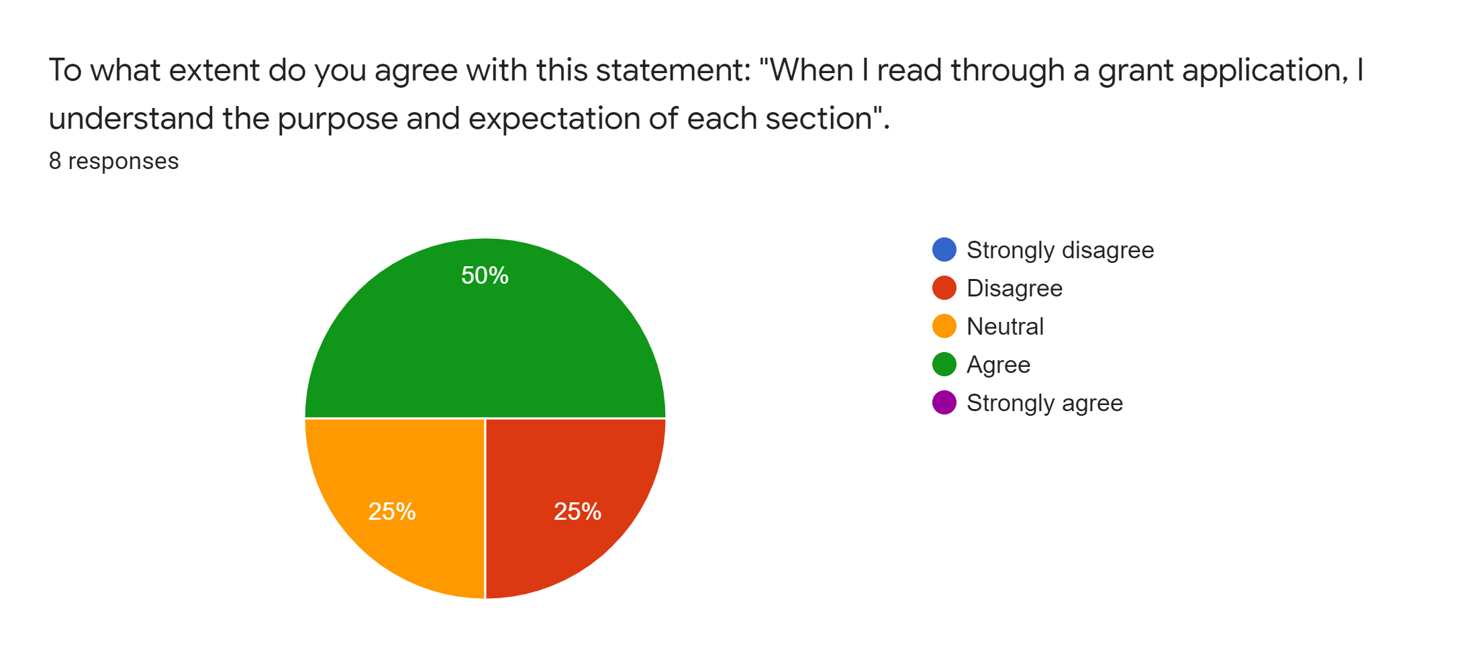
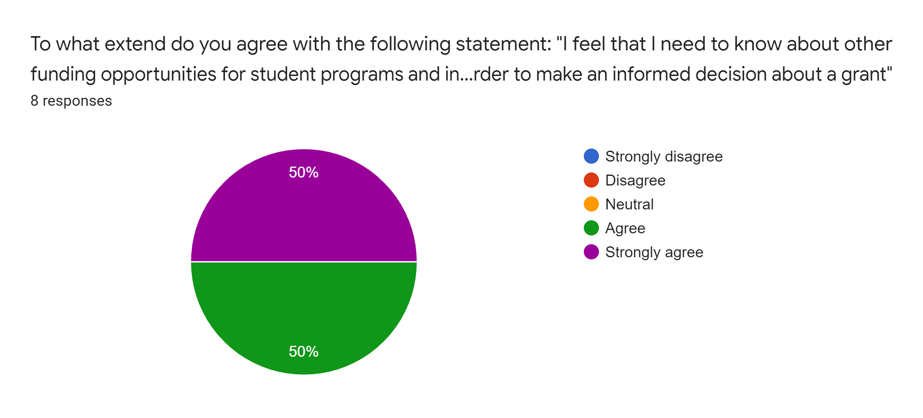
- Relationship with SEF

  - “applicants get referred back and forth between committees and other grant funding sources based on which one may fit most to their application, but because there is a lack of communication between the committees, there is no proper support for these applicants. Also, instead of just passing an applicant back and forth, it would be nice to be able to partner with other funding sources to sponsor an applicant's funding request”
  - “beneficial to have representatives from different committees visit from time to time so we could review grants together and better understand the scope of different funding opportunities.”
  - “the SEJF committee should communicate to other committees when they encounter a submitted project that may better fit with another committee's goals and responsibilities (Ex. Student Enhancement Fund). This could help keep the SEJF committee within their annual operating budget while still ensuring students have equal access to gain funding for their desired programs.”

- Understanding of program

  - ““I would have liked to better understand what the application process looks like for the applicant and would have liked a breakdown of the application itself.”
  - “The application has a lot of information to sift through and it is not entirely very accessible to everyone. I felt that there was not enough transparency all of the time between what the Office of Sustainability knew versus what we as a committee got, it often felt like they knew everything and we had to base our entire judgement off what information they have given us and what the applicant tries to convey in the really long application.”
  - “Background on SEJF, who makes what decisions, how people can apply, etc.”

Program operations and relationship between committee and the program

- Support of SEJF Program Team

  - I think the project coordinators should be utilized for their knowledge on the projects they are working on more often.
  - “Assuming that the program members would know the most about this, I feel like they can provide more input to allow us to make a better decision past just looking at the logistics. I understand that the program members are non-voting members on the committee but I feel like sometimes they can take up more space during the committee than the voting members do when it comes to discussing the applicant before voting.”
  - “I think the project coordinators should be utilized for their knowledge on the projects they are working on more often. We become kind of like the experts (depending on how involved we are) on the projects we are working on. It would be awesome to be seen has having valuable knowledge to inform the committee, I didn't feel like that all the time. It was also hard to speak up.”

- Understanding of budget

  - “Distinguish between encumbered funds vs. yearly funds. Maybe not so much ambiguity needs to be discussed to the committee”
  - “projects that are a few years old or for ones that have not even started yet but have a hold on the money …. we look at them expecting to get some of those funds back but it seems like we never get to know how much is expected to come back or …. uncertain[ty] making it difficult to understand how much is actually in this year's budget...visually organized so that there is a better understanding”
  - “Maybe a password-protected excel budget sheet that shows a small budget calculation before each committee meeting would help. These could be sent out to members sitting on the committee.”

Committee time
- Approval

  - “The two most important things for me is that the budget is clear and itemized and they clearly align themselves with the SEJF mission statement. Further than this, I think the SEJF has really high bars to reach which can be overwhelming for students who have full course loads. How can the application process be simplified to make the process more accessible/appealing in the first place?”
  - “It should be relevant to the mission, have a well-considered and realistic budget, and have buy in from stakeholders.”
  - “I don't think there should be any one example or rule of what gets approved and what does not get approved but that it is a case by case basis. We cannot only fund large scale projects or individual applicants, I think it should be based more so on the content and the purpose of the grant.”

- Aiding Efficacy of members:

  - “Having more time to review the grants themselves, and the agendas. Also, there were many times when we had to wait for a quorum, which wasted time for the rest of us.”
  - “I do feel as though the Office of Sustainability members and some of the faculty and pro-staff take up a lot of time during committee time and there feels like there is not a lot of room or space for the student representatives. I also feel like not enough of the student committee members participate in the discussion of each applicant but just vote towards the end so it is hard to gauge how everyone feels and what everyone thinks about each grant application.”
  - “I feel like I still need a better understanding on how the Office of Sustainability functions/ how they work during the application process. We do not always get the grant applications well in advance and so it is hard to go over all of them in time for a committee especially when they can be difficult to read and understand...spend most of the time during meeting going over any questions, misunderstandings, concerns, etc, leaving us in a pressure to make a poorly informed decision to vote to approve or disapprove towards the end.”

Committee goals
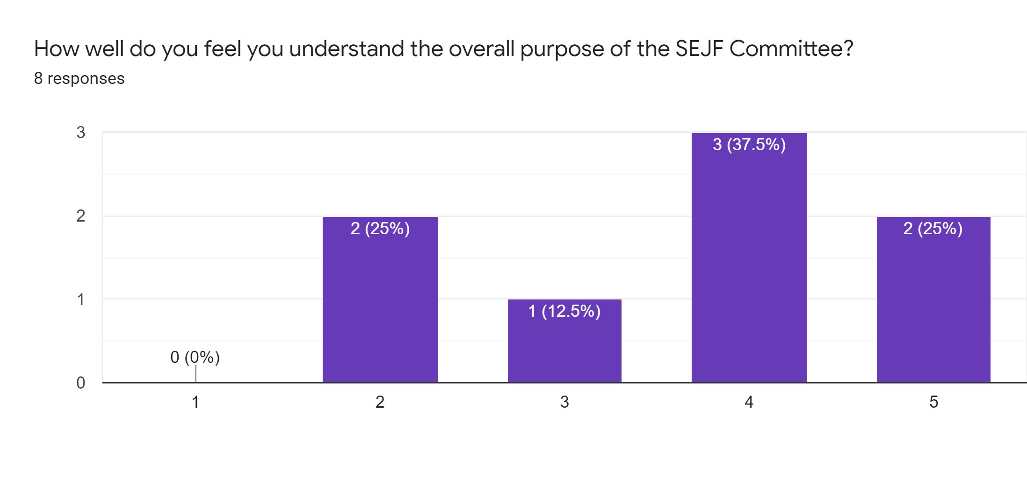
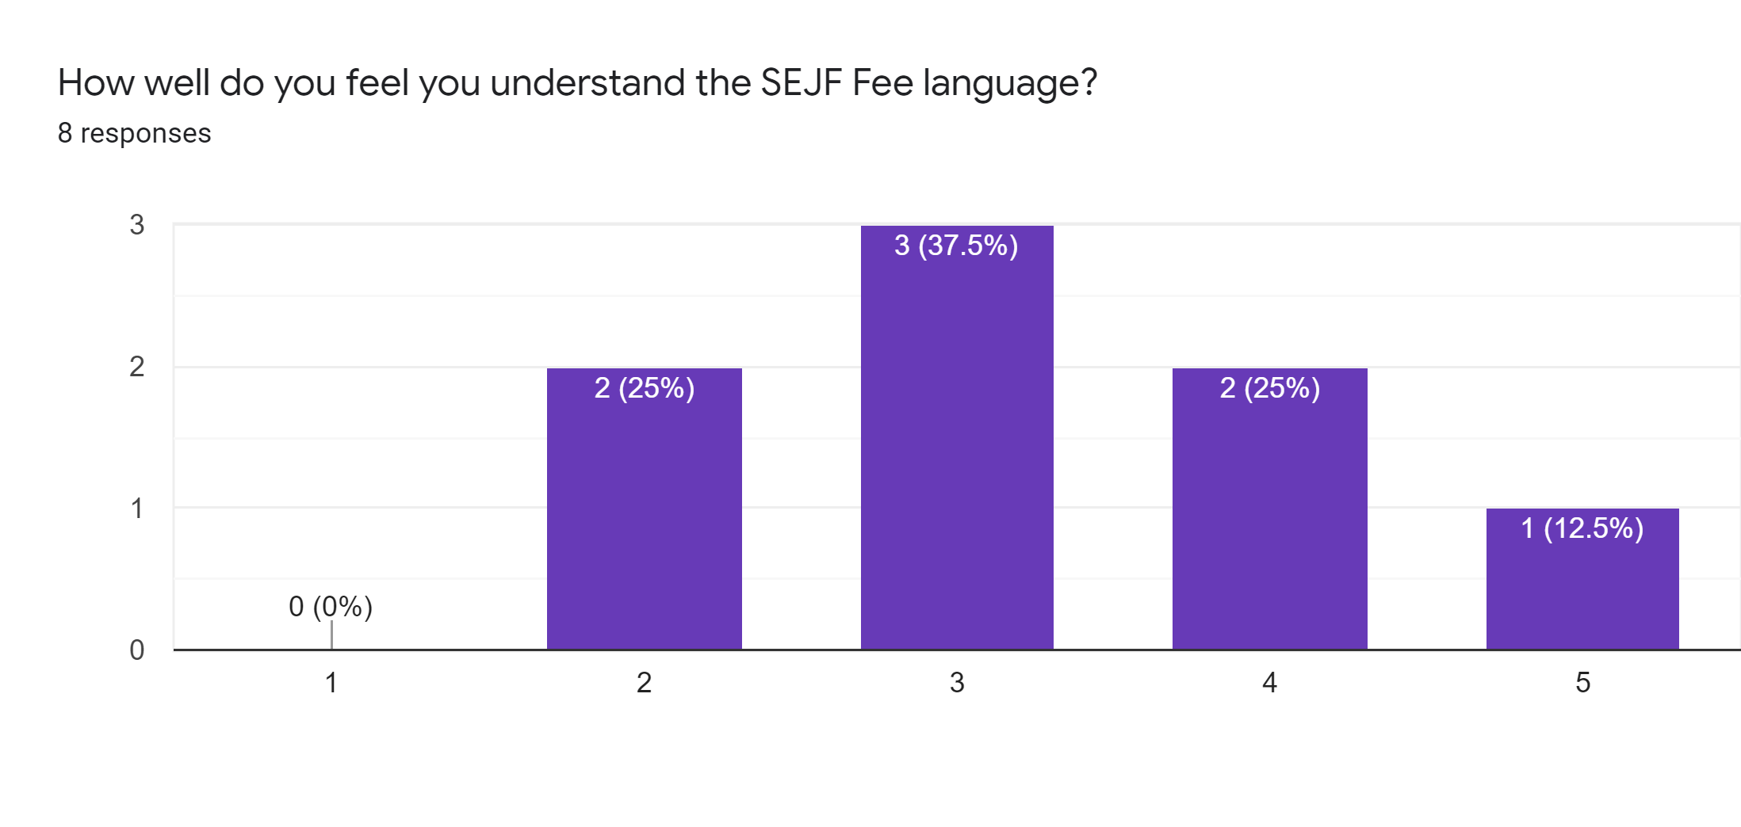
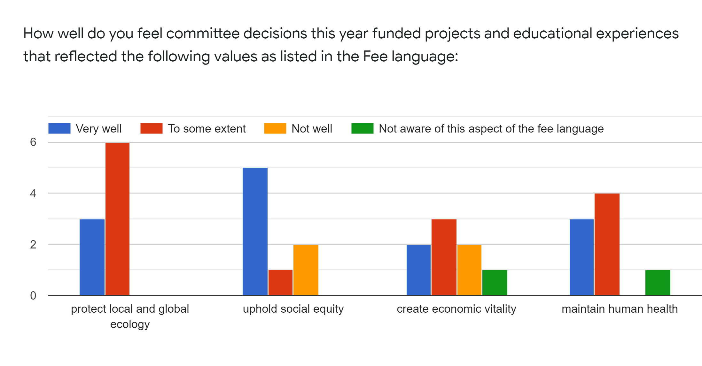
- Balancing the aspects of SEJF, particularly the E, J

  - “Honestly, I miss the days of the SAF. It seems that there are lots of other opportunities for equity & justice on campus. Some of the travel grants were sketchy.”
  - “I get that there is integration of sustainability, equity, AND justice...but how do we balance the three is a key issue. It doesn't have to be contentious. ”
  - “I'm not interested in seeing applications that have a one dimensional view of sustainability, projects need to align themselves with multiple pillars for the strongest application.”
  - “In speaking with the student body about the SEJF, they almost always say that they think their money is going towards making the campus, their community a greener and more sustainable environment for the student. This needs to be true for all proposals we need to be sure that we are being an ethical steward.”

- Being Trustees of the Fee and supporting students through the Fee Language:

  - “I feel like the grants that funded the Office of Sustainability employees to go to conferences like WOHESC or SXSW were not appropriate grants to come to the SEJF committee. I feel that is unfair that such funds are considered a part of the committees purview just because the committee also funds the OS' [SEJF] employment funds and organizational funds. It seems like a misuse of funds and unfair to others who wish to apply to this fund.”
  - “There is a lack of transparency from this committee, only people who sit on this committee would really know what is going on. Even though there are public minutes and agendas they are not very accessible or easy to understand for everyone and most people do not know about this committee and its function because of poor marketing and outreach.”

Additional Things that may be of concern:
  - “want to talk about long term funding; our current model doesn't allow for this, but it is a necessity for sustainability. So many projects never go to completion because they require some regular funding, but nobody wants to house these programs because the university is working with a major deficit.”
  - “moving to a merit based funding model rather than a first-come-first serve.”
  - “I still don't understand what the official position on the Huxley Student Space is supposed to be. There needs to be some major fixes done to our founding documents to prevent these kinds of issues from surfacing again. In particular, it should be required that the SEJF program approves grants to go in front of committee, so they do not go in front of committee before they're ready. We already do a value statement when we accept grant teams and begin to work with them, so this would not expand the role of the program.”
  - “I do believe all of the proposals deserve to be funded, however I do not believe they should all be funded through the SEJF. Perhaps a separate committee should be constructed... that is another matter.”

