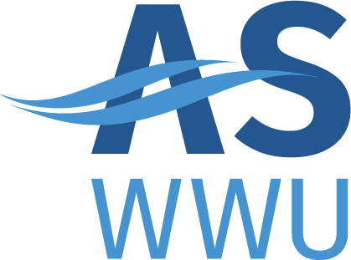
ASWWU Activities Council
MEETING AGENDA
Winter, 2022 | 3/7/22

- REVISIONS TO THE AGENDA
- Approval of Minutes
- Business Director’s Report
  - Olivia report
- Club Recognition (comments from students and the community)
- Club Name Change
- Large Event Fund
  - AS Produtions – $17,000
  - Muslim student association
- Action Items (subject to immediate actions)
- Council Review
- Other Business
.

