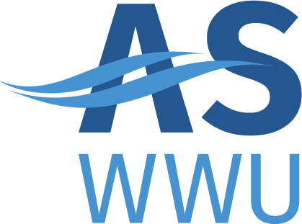
ASWWU Activities Council
MEETING AGENDA
Spring, 2022 | 4/4/22

- REVISIONS TO THE AGENDA
- Approval of Minutes
- Business Director’s Report
  - Olivia’s report
- Club Recognition (comments from students and the community)
- Club Name Change
- Large Event Fund
  - Anti-Cinema Cinema club sponsored with ASP
- Action Items (subject to immediate actions)
- Information Items
  - Khemical Showdown
  - Environmental sustainability
- Bookstore donation
  - Muslim student association
- Council Review
- Other Business
.

