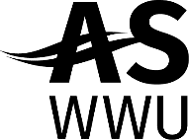 | AS Legislative Affairs Council Agenda
 | November 9nd, 2021 – 4:00pm
 | Virtual Meeting- Microsoft Teams

- Call Meeting to Order
  - Introductions
  - Reminder to View LAC Training Handa

- Additions/Changes to the Agenda

- Information Items
  - Review Previous Lobby Day Agendas Handa
    - Western Lobby Day 2021
    - Western Lobby Day 2020
    - Western Intersectional Lobby Day 2021
    - Western Intersectional Lobby Day 2020
    - Local Lobby Day 2021
    - Local Lobby Day 2019

  - View Draft ASWWU Agenda 2021-22 Huffman & Handa
    - Brainstorm Additional Ideas
    - Plan Next Steps

- Other Business
  - Legislative Priorities Survey Tabling Sign-Up Huffman
  - Update on WA Legislative Session Plans Handa

